**Project Report**Comprehensive Analysis and Dietary Strategies with Tableau: A College Food Choices Case Study

**Team Members**

# Team ID:  LTVIP2025TMID50890

|  |  |
| --- | --- |
| **Team Leader** | Mohan Krishna |
| **Member 1** | M Naggassrii |
| **Member 2** | Lingala Rajesh |
| **Member 3** | Lalith Sai Nadh Ganta |

Contents

Team ID:  LTVIP2025TMID50890 1

1. Problem Statement 5

**1.1 Background** 5

**1.2 Problem Definition** 5

**1.3 Key Challenges Identified** 5

**1.4 Objective of the Solution** 6

2. Brainstorming & Problem Identification 6

2.1 Context and Motivation 6

2.2 Problem Statement 6

2.3 Project Vision 6

2.4 Brainstorming Questions 6

2.5 Tool Selection Rationale 7

3. Empathy Map 7

3.1 Target Persona 7

3.2 Empathy Map Table 7

3.3 Pain Points and Gains 8

3.4 Empathy Insights Summary 8

4. Student Journey Map 9

**4.1 Journey Stages Overview** 9

**4.2 Visual Journey Summary** 9

**4.3 Key Takeaways from the Journey** 10

5. Data Flow Diagram (DFD) 10

**5.1 Overview** 10

**5.2 DFD – Level 1 Description** 10

**5.3 Data Flow Description** 10

**5.4 Key Considerations** 11

6. Technology Stack 11

**6.1 Data Collection & Storage** 11

**6.2 Data Preparation & Transformation** 11

**6.3 Data Visualization** 12

**6.4 Web Integration** 12

**6.5 Deployment (Optional)** 12

**6.6 Supporting Tools** 12

7. Problem–Solution Fit 13

**7.1 Recap of the Problem** 13

**7.2 The Proposed Solution** 13

**7.3 How the Solution Delivers Fit** 13

**7.4 Strategic Value** 14

8. Proposed Solution 14

**8.1 Solution Overview** 14

**8.2 Key Solution Components** 14

**8.3 Functional Architecture** 15

**8.4 Features of the Proposed Solution** 15

**8.5 Benefits of the Proposed Solution** 15

9. Solution Architecture 16

**9.1 Overview** 16

**9.2 Architecture Layers** 16

**9.3 Architecture Diagram** 16

**9.4 Key Characteristics** 17

**9.5 Advantages of the Architecture** 17

10. Project Planning 18

**10.1 Team Details** 18

**10.2 Project Duration** 18

**10.3 Weekly Timeline** 18

**10.4 Milestones and Deliverables** 18

**10.5 Tools and Platforms** 19

11. Project Executable 19

11.1 Creating the data visualizations 19

11.2 Design of Dashboard 27

12. Performance Testing of Visualizations 29

**12.1 Objective** 29

**12.2 Key Performance Metrics** 29

**12.3 Testing Parameters** 30

**12.4 Tools Used** 30

**12.5 Test Results Summary** 30

**12.6 Recommendations for Optimization** 30

**12.7 Conclusion** 31

**13. Deployment of Flask Web Application with Embedded Tableau Dashboard** 31

**13.1 Overview** 31

**13.2 Hosting Platform** 31

**13.3 Project Structure** 31

**13.4 Key Configuration Files** 32

**13.5 Deployment Process** 32

**13.6 Issue Encountered and Resolution** 33

**13.13 Final Result** 33

**13.8 Conclusion** 33

# 1. Problem Statement

**1.1 Background**

In recent years, there has been growing concern about the **dietary habits of college students**, which directly affect their academic performance, physical health, mental well-being, and lifestyle choices. Busy academic schedules, lack of nutritional awareness, social pressures, limited cooking facilities, and accessibility to processed foods contribute to irregular and often unhealthy eating patterns.

Despite the availability of cafeteria meals and food delivery apps, students often face challenges in maintaining a **balanced and nutritious diet**. This problem is compounded by a lack of access to **visual, personalized dietary insights** that could help them make informed decisions.

**1.2 Problem Definition**

"How can we leverage interactive data visualizations to analyze, monitor, and improve the dietary patterns and nutritional habits of college students?"

There is a need for a centralized, user-friendly platform that transforms raw dietary data into meaningful visual insights for students, health professionals, and university administrators. Such a platform should:

* Track key health indicators (e.g., calorie intake, food diversity, vitamin consumption)
* Identify patterns such as meal skipping, junk food dependency, or low fruit/vegetable intake
* Support real-time monitoring of trends across demographics
* Provide predictive insights for early interventions and personalized nutrition planning

**1.3 Key Challenges Identified**

| **Challenge** | **Impact** |
| --- | --- |
| Lack of personalized nutrition tracking | Students unable to make data-driven food choices |
| Poor visibility into eating habits over time | No way to identify unhealthy patterns early |
| Limited real-time monitoring tools | Universities can’t intervene proactively |
| No integrated visualization system for stakeholders | Administrators, students, and nutritionists lack a common analytical view |

**1.4 Objective of the Solution**

To address the above challenges, this project proposes the creation of a **data analytics solution using Tableau**, integrated into a web-based interface using Flask. The goal is to:

* Enable dynamic dashboards for in-depth dietary analysis
* Provide actionable insights based on real student data
* Help educational institutions make informed, health-driven decisions
* Promote long-term well-being by encouraging smart food choices through data

# 2. Brainstorming & Problem Identification

## 2.1 Context and Motivation

In modern academic environments, the dietary habits of college students have a significant influence on their physical well-being, mental health, and academic performance. With busy schedules, inconsistent meal patterns, and limited nutritional awareness, students often fall into unhealthy eating routines. This challenge presents an opportunity for data-driven intervention.

## 2.2 Problem Statement

*"How can we leverage data visualization tools to monitor, understand, and improve the dietary choices of college students?"*

## 2.3 Project Vision

The project aims to build a comprehensive, interactive dashboard using Tableau, integrated into a Flask-based web platform. This system will visualize complex dietary datasets and help universities:

## 2.4 Brainstorming Questions

During ideation, the following guiding questions shaped the analytical and technical scope of the project:

* What dietary patterns can be identified across student demographics?
* How do lifestyle habits (e.g., cooking, exercise, sleep) correlate with GPA and self-perceived health?
* Can real-time data visualization help in early identification of health issues?
* How can data be used to encourage healthier eating habits institution-wide?

## 2.5 Tool Selection Rationale

* **Tableau:** For its powerful data visualization, ease of data preparation, and dynamic dashboard creation.
* **Flask:** To create a lightweight yet flexible web interface for hosting the dashboards.
* **CSV Dataset:** A structured and easily readable format for dietary, behavioral, and demographic data.

# 3. Empathy Map

Understanding the users — *college students* — is essential to designing meaningful visual analytics. The empathy map below represents a structured understanding of their thoughts, feelings, behaviors, and pain points, which inform how the data should be visualized and interpreted.

## 3.1 Target Persona

| **Attribute** | **Description** |
| --- | --- |
| **User Type** | Undergraduate and graduate college students |
| **Age Group** | 18 – 35 years |
| **Location** | Primarily living on-campus or off-campus in urban college areas |
| **Lifestyle Factors** | Busy schedules, budget constraints, frequent exams, exposure to fast food |
| **Health Consciousness** | Moderate to low awareness of nutritional content in daily meals |

## 3.2 Empathy Map Table

|  |
| --- |
| - Unhealthy food readily available  - Peers with similar poor food habits  - Limited awareness campaigns about health and nutrition |

|

| **What they HEAR** | - “It’s okay to skip meals when you're busy.”  
- “Junk food is cheap and convenient.”  
- “Healthy food is expensive.”  
- Health advice from family, friends, social media influencers |  
| **What they THINK & FEEL**| - “I want to eat healthier but it’s too hard.”  
- Guilt after overeating or skipping meals  
- Anxiety about weight and health  
- A desire for personalized and easy-to-follow nutrition guidance |  
| **What they SAY & DO** | - “I don’t have time to cook.”  
- Frequently order takeout or eat in campus cafes  
- Rarely read food labels  
- Share meal photos on social media |

## 3.3 Pain Points and Gains

| **Pain Points (Challenges)** | **Gains (Goals & Motivations)** |
| --- | --- |
| ❌ Lack of time and motivation to cook or plan meals | ✅ Want to improve health and focus |
| ❌ Limited awareness about nutritional content | ✅ Prefer personalized nutrition plans |
| ❌ High cost of healthy food options | ✅ Want affordable, healthy food alternatives |
| ❌ Irregular eating patterns due to classes, work, and social commitments | ✅ Seek visual guidance and data-driven tips to form better habits |
| ❌ Poor cafeteria options and fast food dependency | ✅ Want quick insights into their diet to take corrective steps |

## 3.4 Empathy Insights Summary

By diving into the students’ perspectives, we discovered a significant **gap between intent and behavior**. Students want to eat better and live healthier lives, but lack of information, time, and affordability become major barriers. This empathy-driven understanding allowed us to design **data visualizations in Tableau that are intuitive, personalized, and directly actionable** — not just technical, but human-centered.

# 4. Student Journey Map

The Customer Journey Map outlines the **end-to-end experience of a student user** engaging with the dietary analysis dashboard. This visualization helps identify key touchpoints, emotional responses, and areas for improving engagement and usability of the system.

**4.1 Journey Stages Overview**

| **Stage** | **Student Actions** | **Touchpoints** | **Emotions** | **Opportunities for Improvement** |
| --- | --- | --- | --- | --- |
| **Awareness** | Learns about the dashboard from campus wellness center, email, or peer sharing | Health workshops, campus emails, posters | Curious, Interested | Promote with engaging visuals, show key benefits at a glance |
| **Engagement** | Logs in to view personal or general dietary trends and insights | Dashboard web app (Flask), mobile view | Excited, Slightly Confused | Provide onboarding or tooltips to explain visuals |
| **Exploration** | Explores visualizations: calories, habits, preferences, deficiencies | Tableau charts, filters, story scenes | Surprised, Engaged | Allow filtering by gender, exercise, or cuisine for personalization |
| **Realization** | Discovers unhealthy patterns (e.g., high junk food, low veggies) | Interactive graphs, diet scorecard | Concerned, Reflective | Add personalized tips and suggestions |
| **Action** | Takes action: alters diet, joins health program, shares insights | External health links, contact forms | Motivated, Empowered | Integrate links to campus dieticians or meal plan generators |
| **Retention** | Re-visits the dashboard periodically to check progress | Browser bookmarks, mobile access | Confident, Satisfied | Set reminders or allow saving progress snapshots |

**4.2 Visual Journey Summary**

Here’s a visual breakdown of the student’s emotional journey across stages:

|  |
| --- |
| Awareness ──► Engagement ──► Exploration ──► Realization ──► Action ──► Retention  😐 🙂 😮 😟 💪 😊 |

**4.3 Key Takeaways from the Journey**

* Students experience **increased emotional investment** once they start identifying real issues through visuals.
* Dashboards must be **intuitive and context-aware** to sustain engagement.
* There’s a strong opportunity to use **data storytelling** for improving student health outcomes.
* **Timely guidance** (based on data insights) can convert awareness into sustainable action.

# 5. Data Flow Diagram (DFD)

**5.1 Overview**

The Data Flow Diagram (DFD) illustrates the movement of data through the different components of the *College Food Choices Visualization Project*. It captures how raw data is collected, processed, visualized, and presented to end users through an interactive web interface.

This diagram highlights the major components involved, including data sources, preprocessing tools, visualization engine (Tableau), and the web embedding system (Flask).

**5.2 DFD – Level 1 Description**

| **Component** | **Description** |
| --- | --- |
| **1. Data Source (CSV)** | Dietary and lifestyle data collected in structured CSV format |
| **2. Data Cleaning & Prep** | Preprocessing in Tableau Prep or directly in Tableau Desktop for filtering, joining, and formatting |
| **3. Tableau Dashboard** | Interactive visualizations built using Tableau Desktop |
| **4. Tableau Server / Public** | Dashboard hosted on Tableau Public or Tableau Server for embedding |
| **5. Flask Web App** | Lightweight Python-based web application to embed and serve Tableau dashboards |
| **6. End Users** | Students, nutritionists, university staff — access insights via browser |

**5.3 Data Flow Description**

|  |
| --- |
| A[CSV Dataset<br>Raw Student Data] --> B[Data Cleaning<br>Tableau Prep / Desktop]  B --> C[Tableau Dashboard<br>Visualizations Built]  C --> D[Tableau Public / Server<br>Hosted Dashboards]  D --> E[Flask Web App<br>Dashboard Embedded in HTML]  E --> F[End User<br>Views Dashboard in Browser] |

**5.4 Key Considerations**

* **Security:** The data does not include sensitive personal details, ensuring privacy while still delivering insight.
* **Scalability:** The system can support additional data sources or student cohorts in future phases.
* **Flexibility:** Tableau Public allows fast updates; changes to the dataset reflect in real-time visuals.

# 6. Technology Stack

The following tools and technologies were carefully selected to design, develop, and deploy the *College Food Choices Case Study Visualization Platform*. The goal was to ensure an intuitive, high-performance solution for analyzing and presenting student dietary data.

**6.1 Data Collection & Storage**

| **Tool / Technology** | **Purpose** |
| --- | --- |
| **CSV Files** | Raw data storage format used for dietary and lifestyle data |
| **Excel / Google Sheets** | Initial formatting and exploration of datasets |

**6.2 Data Preparation & Transformation**

| **Tool / Technology** | **Purpose** |
| --- | --- |
| **Tableau Prep** (Optional) | Data cleansing, column filtering, joining multiple tables |
| **Tableau Desktop** | Importing CSV data, building calculated fields, structuring dashboards |

**6.3 Data Visualization**

| **Tool / Technology** | **Purpose** |
| --- | --- |
| **Tableau Desktop** | Core platform for creating interactive visualizations |
| **Tableau Public / Server** | Hosting the dashboards for external access |

**6.4 Web Integration**

| **Tool / Technology** | **Purpose** |
| --- | --- |
| **Python** | Backend scripting and logic |
| **Flask Framework** | Embedding Tableau dashboards in a minimal web UI |
| **HTML / CSS** | Styling and structuring the web interface |

**6.5 Deployment (Optional)**

| **Platform** | **Purpose** |
| --- | --- |
| **Render / Vercel** | Hosting the Flask application online |
| **GitHub** | Version control and source code repository |

**6.6 Supporting Tools**

| **Tool** | **Purpose** |
| --- | --- |
| **VS Code / Jupyter** | Code development and testing environments |
| **Mermaid / draw.io** | Visualizing system architecture and data flow diagrams |
| **OBS / Screen Recorder** | Recording project walkthroughs and demonstrations |

# 7. Problem–Solution Fit

**7.1 Recap of the Problem**

College students face multiple challenges that hinder their ability to maintain a healthy diet, such as:

* **Irregular meal patterns** due to hectic academic schedules
* **Lack of awareness** regarding nutritional values of food
* **Easy access to fast food** and limited affordable healthy alternatives
* **Minimal data-driven support** from institutions to encourage healthier behavior

These issues are not just isolated to individual health but can contribute to reduced academic focus, long-term health problems, and increased pressure on campus health services.

**7.2 The Proposed Solution**

The solution developed in this project addresses these concerns through an interactive, data-driven platform powered by Tableau and integrated via Flask.

| **Problem Area** | **Solution Feature** |
| --- | --- |
| Unawareness of diet impact | Tableau dashboards visualizing diet vs GPA, exercise, and health perception |
| Lack of real-time insight | Live and interactive dashboards with filtering by demographics and food habits |
| No personalized guidance | Visualization of ideal vs actual dietary behavior, enabling self-assessment |
| Hard to track food trends | Time-based visualizations showing fruit/veggie intake, junk food consumption |
| No intervention tools for institutions | Admin-level overviews to support awareness campaigns and strategic meal planning |

**7.3 How the Solution Delivers Fit**

| **Fit Dimension** | **Explanation** |
| --- | --- |
| **Target User Match** | Designed specifically for students, university staff, and campus nutritionists |
| **Insight Accessibility** | Visual storytelling converts complex datasets into digestible insights |
| **No Learning Curve** | User-friendly dashboards with no login or training required |
| **Actionability** | Enables both self-improvement for students and strategic actions for staff |
| **Scalability** | Can be extended with more data, filters, or even personalized student views |

**7.4 Strategic Value**

This solution does more than visualize data — it **empowers decision-making**:

* 🧑‍🎓 **Students** learn more about their own health habits
* 🏫 **Institutions** gain insights for policy, menus, and campus wellness programs
* 📊 **Data Analysts / Researchers** gain access to structured insights for ongoing study

In essence, the system builds a bridge between data and well-being — making health awareness **visual, personal, and actionable**.

# 8. Proposed Solution

**8.1 Solution Overview**

To address the lack of dietary awareness and nutritional insight among college students, this project proposes a **data-driven dietary analysis platform** built using Tableau for visual analytics and Flask for web-based dashboard embedding.

The proposed solution transforms raw CSV data about students’ food habits, health perceptions, and lifestyle behaviors into **meaningful visualizations**, making the data actionable and insightful for both individuals and institutional decision-makers.

**8.2 Key Solution Components**

| **Component** | **Description** |
| --- | --- |
| **Tableau Dashboards** | Used to build interactive and real-time visuals representing dietary patterns |
| **CSV Dataset** | Source of raw data with over 30 columns on food habits, health, and lifestyle |
| **Data Cleaning Module** | Optional use of Tableau Prep or Excel to ensure clean, formatted data |
| **Story Boards** | Tableau "Story" feature used to create narrative flow across multiple visuals |
| **Flask Integration** | Lightweight web application to host and embed the dashboard for browser access |

**8.3 Functional Architecture**

[CSV Dataset]

↓

[Data Cleaning & Preparation]

↓

[Tableau Desktop]

→[Dashboard + Story Creation]

↓

[Tableau Public / Server]

↓

[Flask Web App]

↓

[End User (Students / Staff / Admins)]

You can optionally convert the above text diagram into a visual one using tools like Lucidchart, Canva, or draw.io.

**8.4 Features of the Proposed Solution**

| **Feature** | **Purpose** |
| --- | --- |
| ✅ **Interactive Filtering** | View trends by gender, GPA, diet type, exercise frequency |
| ✅ **Nutritional Trends Analysis** | Analyze intake of fruits, vegetables, vitamins, and fast foods |
| ✅ **Diet vs. Academic Correlation** | Study how diet affects GPA, healthy feelings, and self-perception |
| ✅ **Storytelling Scenes** | Visual narratives showing evolving trends or comparisons |
| ✅ **Web Embedding** | Dashboard embedded into a Flask web interface for seamless access |

**8.5 Benefits of the Proposed Solution**

* 📊 **Data-Driven Awareness**: Encourages students to reflect on their food habits
* 🏥 **Institutional Planning**: Helps universities deploy targeted wellness initiatives
* 📈 **Scalability**: The system can be extended with more data fields or updated datasets
* 🖥️ **Accessibility**: No login or complex setup; dashboards are public and responsive

This solution transforms raw dietary data into a **personalized, visual experience** — providing stakeholders with the tools needed to promote better nutrition, healthier habits, and improved student outcomes.

# 9. Solution Architecture

**9.1 Overview**

The *College Food Choices Visualization System* follows a **modular and scalable architecture**, designed to ingest raw data, process it into insightful dashboards using Tableau, and present it through a Flask-based web application for user access.

This architecture supports **ease of data preparation, visual storytelling, and seamless user interaction** — with minimal backend complexity and high usability.

**9.2 Architecture Layers**

| **Layer** | **Description** |
| --- | --- |
| **Data Layer** | Stores structured CSV files containing dietary, lifestyle, and health metrics |
| **Preparation Layer** | Cleans and transforms data using Tableau Prep or Excel |
| **Visualization Layer** | Creates interactive dashboards and storyboards in Tableau Desktop |
| **Hosting Layer** | Publishes dashboards on Tableau Public or Tableau Server |
| **Web Interface Layer** | Uses Python Flask to embed the dashboard inside a clean web UI |
| **User Access Layer** | Students, researchers, and faculty access the dashboards via browsers |

**9.3 Architecture Diagram**

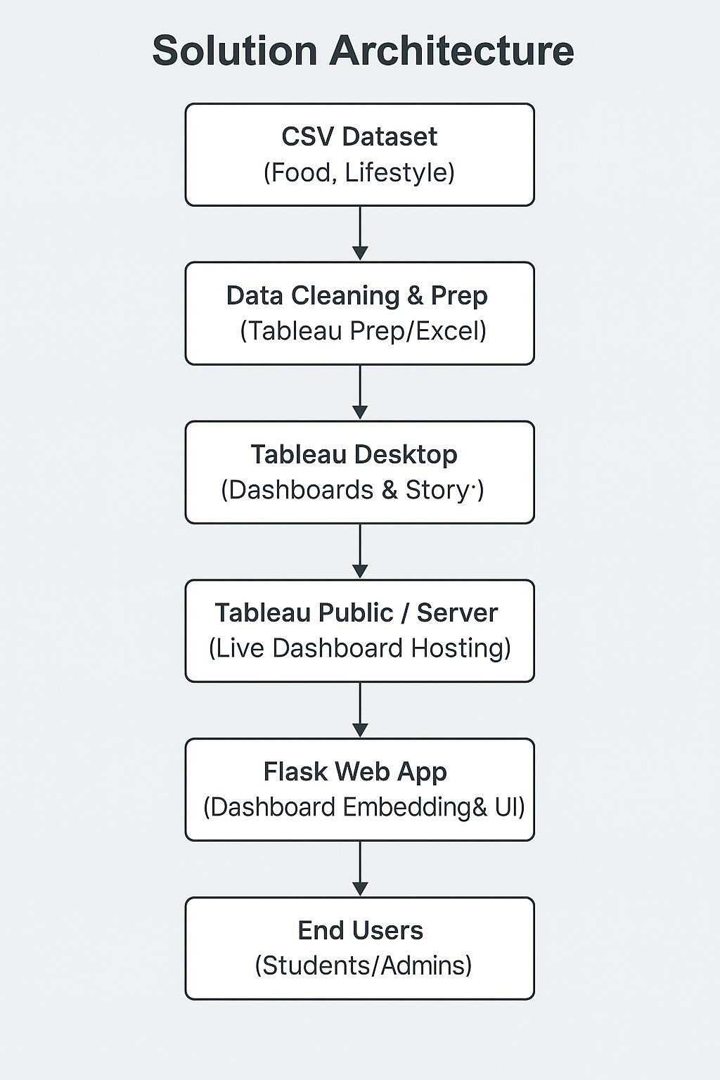You can visualize the architecture as follows:

You can create a **visual diagram** from this using draw.io, Canva, or Lucidchart for your final report/PPT.

**9.4 Key Characteristics**

| **Characteristic** | **Details** |
| --- | --- |
| **Modularity** | Each layer functions independently, allowing easy updates and scaling |
| **Lightweight Backend** | Flask used solely for front-end embedding; no heavy backend logic involved |
| **Platform Independent** | Dashboards are web-based and work on all major browsers and devices |
| **Security Compliant** | No PII involved; dashboards are shared securely via Tableau Public/Server |
| **Extensibility** | Future datasets can be integrated with minimal changes to the architecture |

**9.5 Advantages of the Architecture**

* ✅ **Quick Development Cycle** – Rapid prototyping using Tableau
* ✅ **Seamless Deployment** – Minimal setup using Flask and Tableau Public
* ✅ **User-Centric Interface** – Designed for students, staff, and health professionals
* ✅ **Maintainable & Scalable** – Easily update data, visuals, or embed logic

# 10. Project Planning

This section outlines the timeline, team structure, and key deliverables planned for the successful execution of the *Comprehensive Analysis and Dietary Strategies with Tableau: A College Food Choices Case Study*.

**10.1 Team Details**

| **Attribute** | **Information** |
| --- | --- |
| **Team ID** | LTVIP2025TMID50890 |
| **Team Size** | 4 Members |
| **Team Leader** | Mohan Krishna |
| **Team Members** | M Naggassrii,  Lingala Rajesh,  Lalith Sai Nadh Ganta |

**10.2 Project Duration**

| **Start Date** | **End Date** | **Total Duration** |
| --- | --- | --- |
| 13 June 2025 | 26 June 2025 | 14 Days |

**10.3 Weekly Timeline**

| **Date Range** | **Planned Activities** |
| --- | --- |
| **June 13 – June 15** | Understanding dataset, defining problem statement, team role assignment |
| **June 16 – June 18** | Data cleaning and preparation in Tableau / Excel; start dashboard design |
| **June 19 – June 21** | Building Tableau dashboards and stories; integrate into Flask web app |
| **June 22 – June 24** | Performance testing, user feedback, web embedding refinement |
| **June 25 – June 26** | Final review, documentation, recording video demo, and report submission |

**10.4 Milestones and Deliverables**

| **Milestone** | **Expected Output** | **Due Date** |
| --- | --- | --- |
| Problem Definition & Planning | Clear articulation of problem and architecture diagram | 15 June 2025 |
| Data Cleaning & Structure Final | Cleaned dataset + visual-ready fields | 18 June 2025 |
| Tableau Dashboard Completion | Fully functional dashboards and story scenes | 21 June 2025 |
| Flask Web Integration | Embedded dashboard in Flask UI | 24 June 2025 |
| Documentation & Video Demo | PDF Report, Empathy Maps, Diagrams, and Screencast | 26 June 2025 |

**10.5 Tools and Platforms**

| **Category** | **Tools Used** |
| --- | --- |
| Data Analysis | Tableau Desktop, Tableau Prep (optional) |
| Web Interface | Python Flask, HTML/CSS |
| Documentation & Planning | Google Docs, Canva, VS Code |
| Communication | WhatsApp / Google Meet |

# 11. Project Executable

The **Project Executable** is the functional output of the entire workflow developed for analyzing college students’ food choices*. It includes the core implementation that transforms raw data into meaningful insights through preprocessing, visualization, and interaction.*

## 11.1 Creating the data visualizations

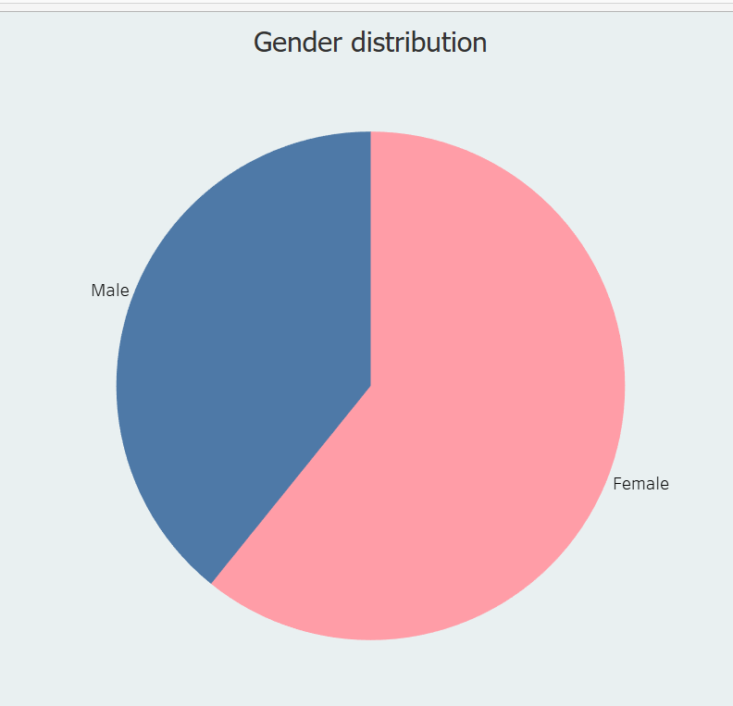Activity 1.1: Gender Distribution:

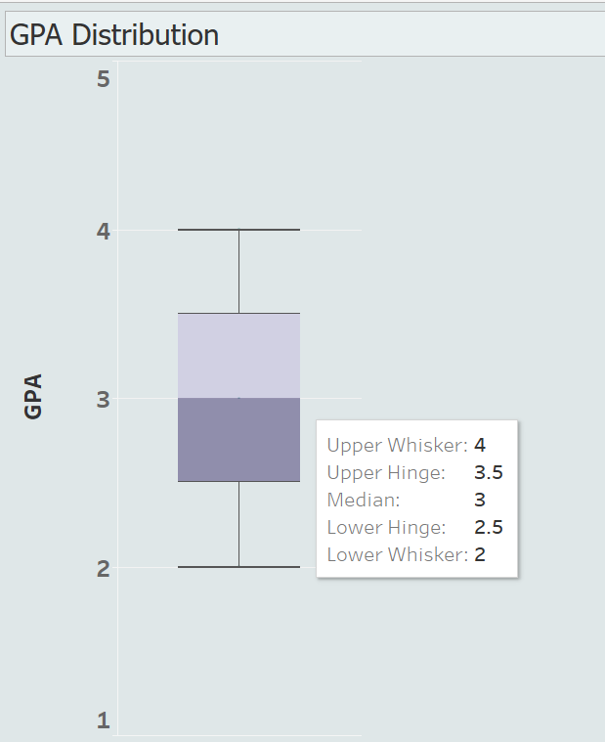 Activity 1.2: GPA Distribution

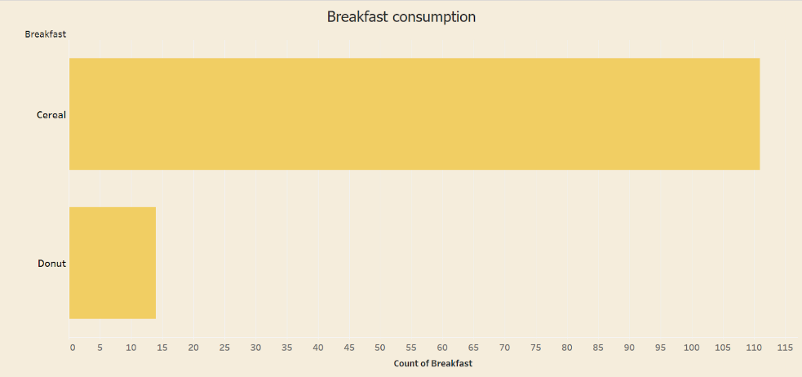Activity 1.3: Breakfast Consumption

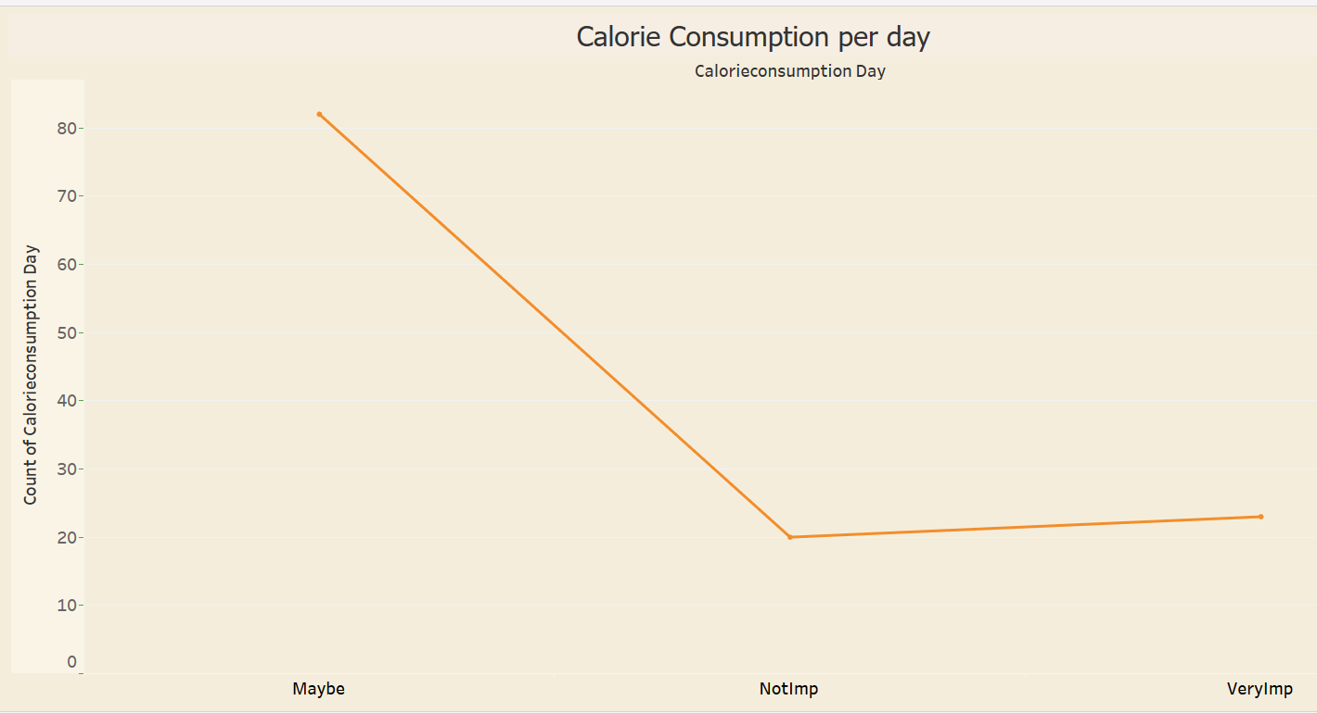Activity 1.4 : Calorie Consumption per day

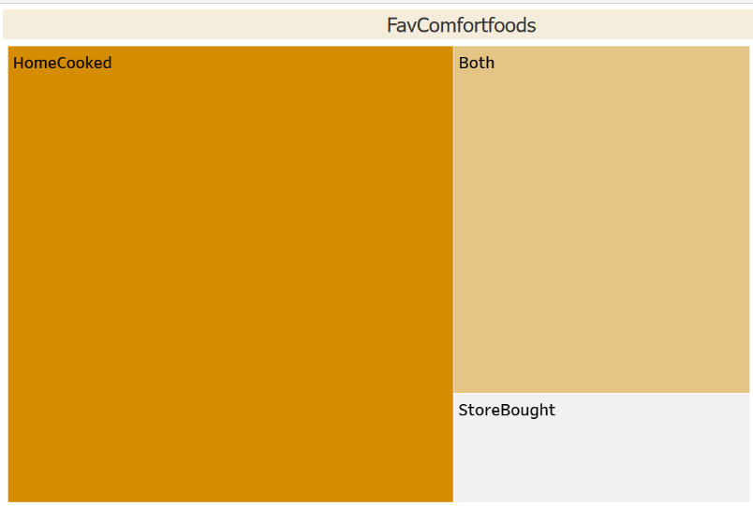Activity 1.5 : Favorite comfort foods

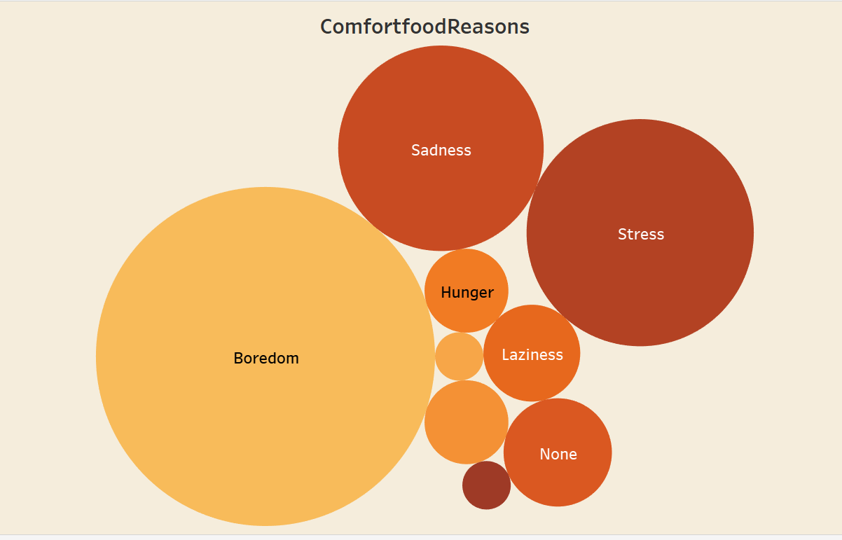Activity 1.6 : Comfort food reasons

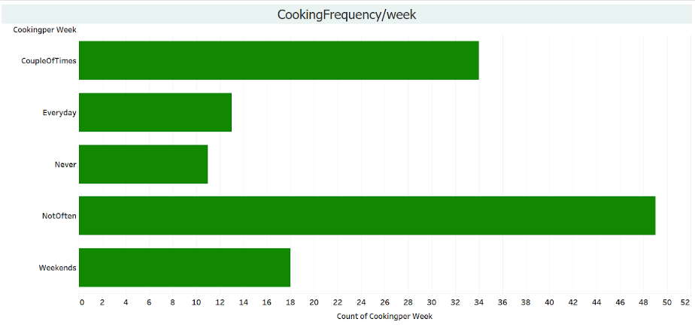Activity 1.7 : Cooking frequency per week

Activity 1.8 : Cuisine preferences

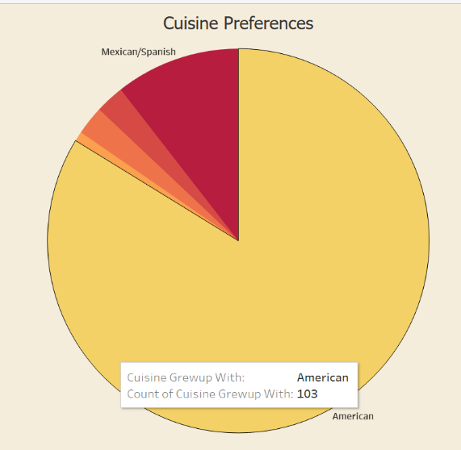

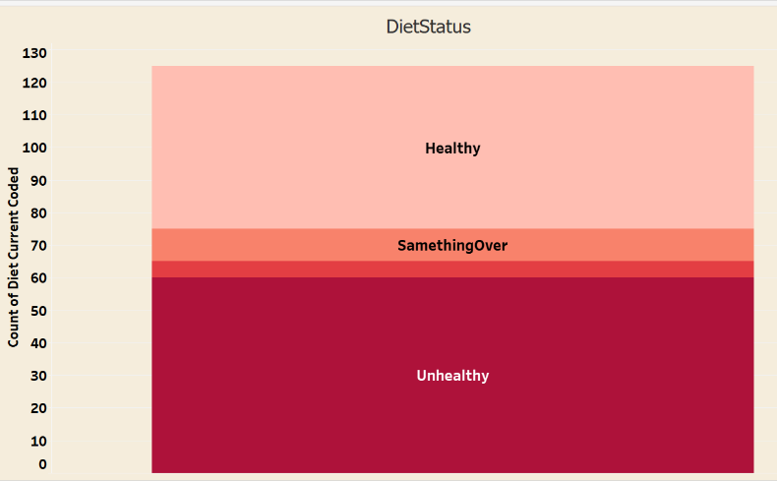Activity 1.9 : Diet Status

Activity 1.10 : Exercise Frequency

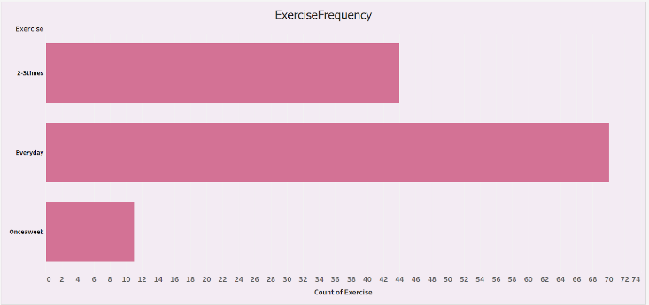

Activity 1.11 : Employee status

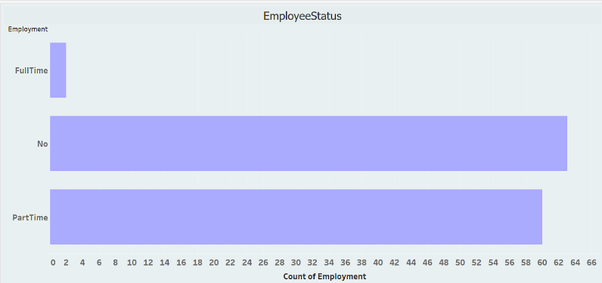

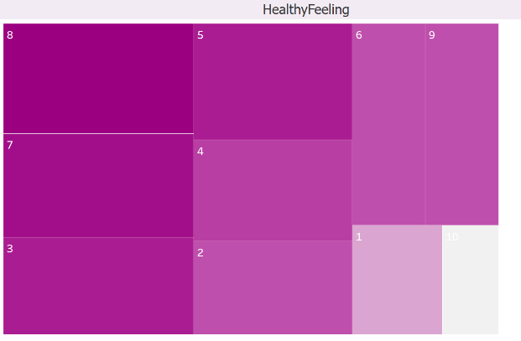Activity 1.12 : Healthy Feeling

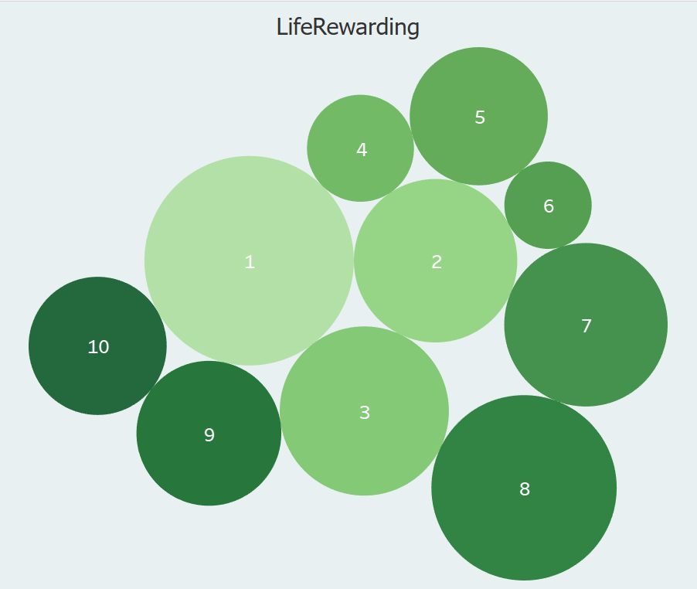Activity 1.13 : Life Rewarding rating

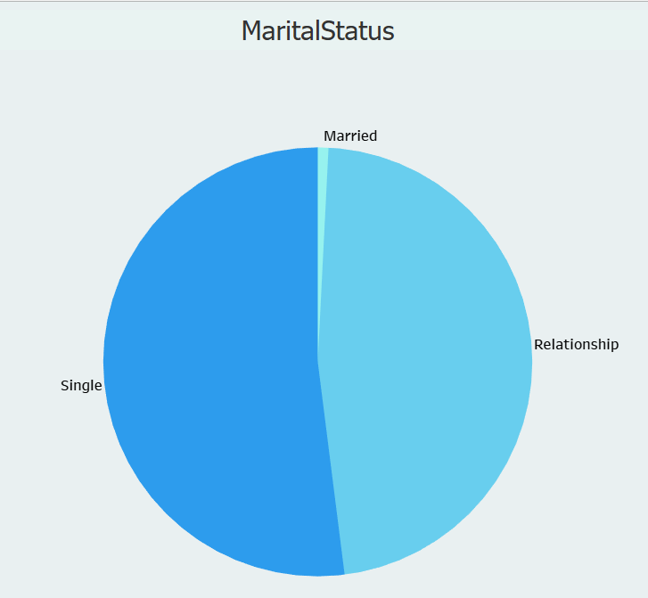Activity 1.14 : Marital status

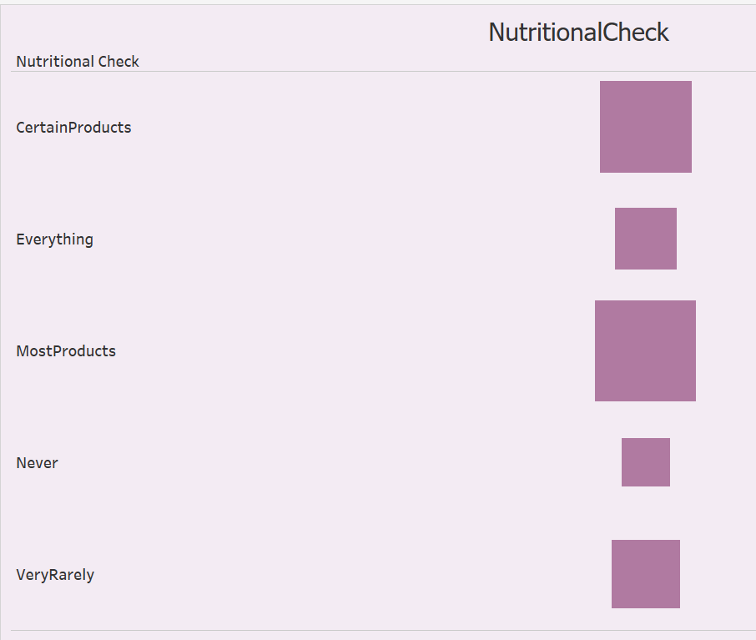Activity 1.15 : Nutritional Check

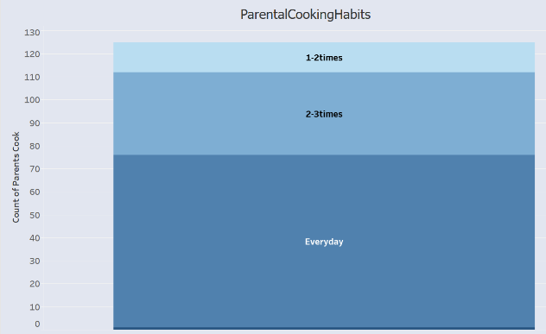Activity 1.16 : Parental Cooking Habits

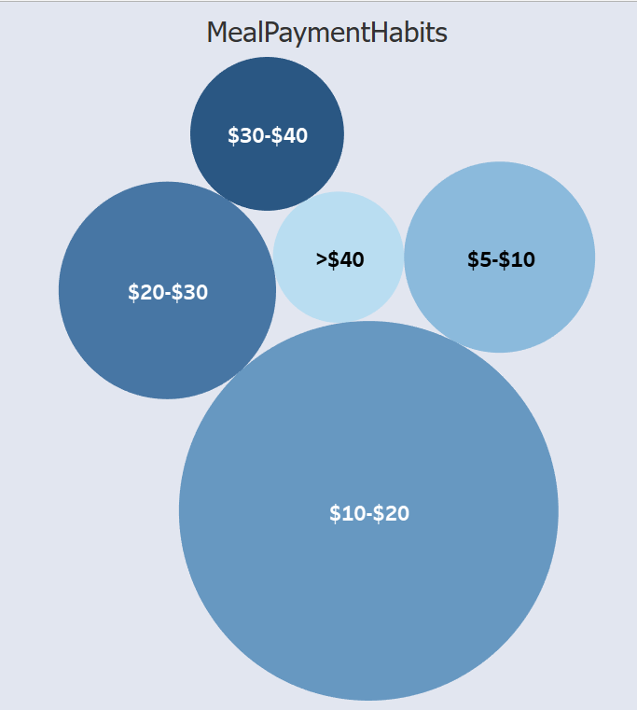 Activity 1.17 : MealPaymentHabits

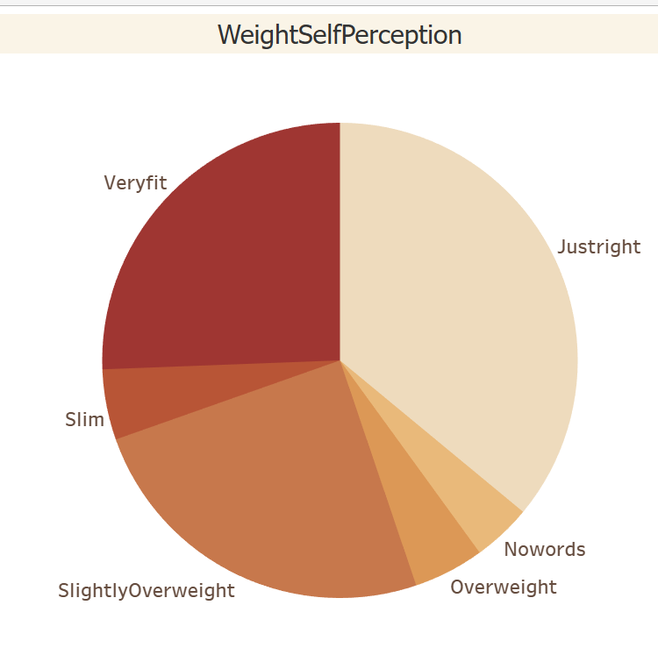Activity 1.18 : Weight Self Perception

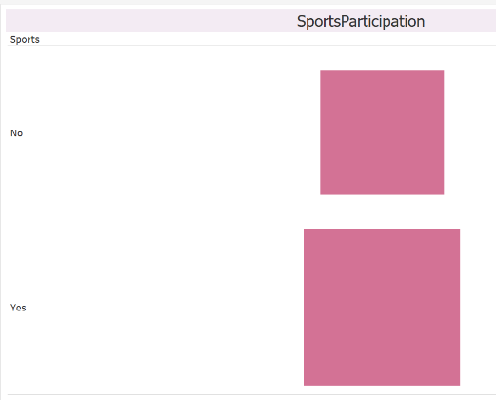Activity 1.19 : Sports participation

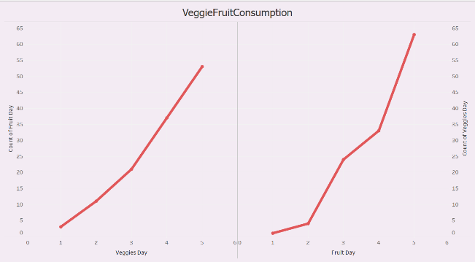Activity 1.20 : Veggieandfruit_Consumption

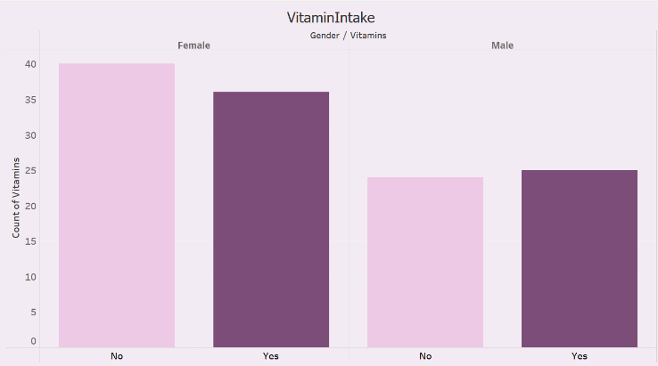Activity 1.21 : Vitamin Intake

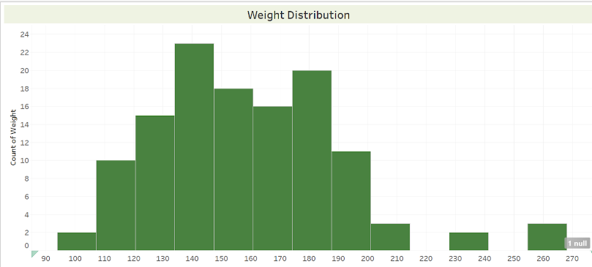Activity 1.22 : Weight

## 11.2 Design of Dashboard

Activity.1 Life Style overview

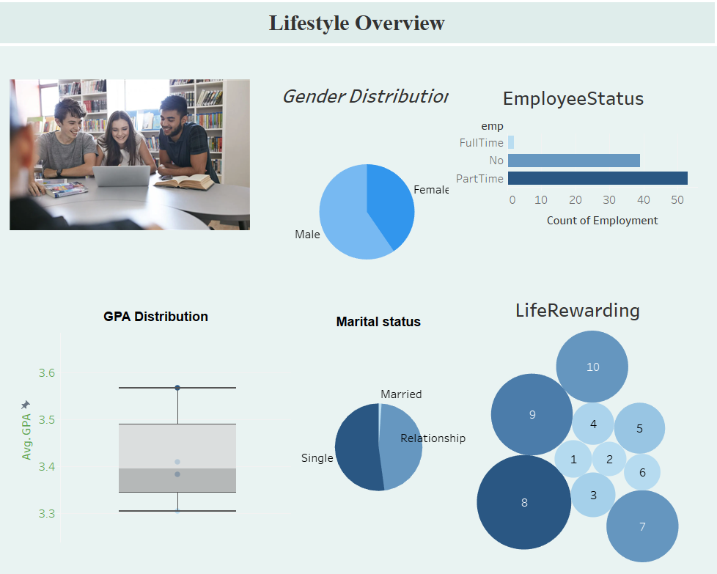

Activity 2 .Dietary Habits and Preferences

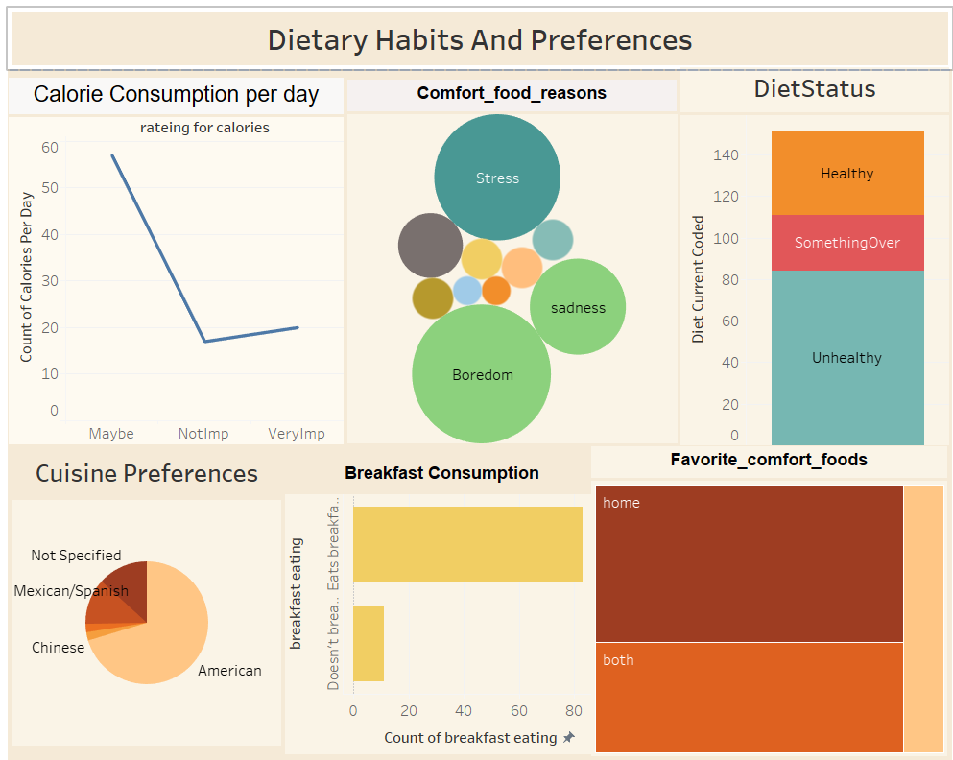

Activity 2 Health and Nutrition

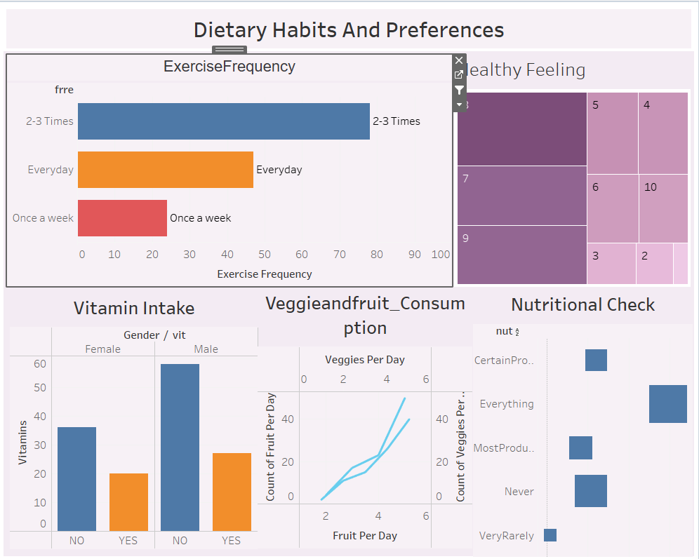

Activity 3

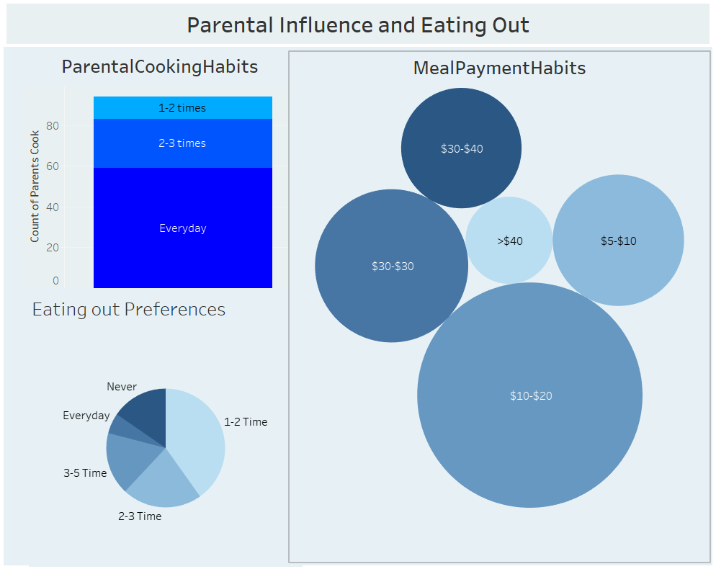

# 12. Performance Testing of Visualizations

**12.1 Objective**

The goal of performance testing is to evaluate the **efficiency, responsiveness, and scalability** of the Tableau dashboards created for analyzing college food choices. Performance tests ensure that the visualizations load quickly, render correctly across devices, and remain responsive during user interaction such as filtering or switching scenes.

**12.2 Key Performance Metrics**

| **Metric** | **Description** |
| --- | --- |
| **Dashboard Load Time** | Time taken for the dashboard to load completely after initial access |
| **Visualization Rendering Time** | Time taken to load individual charts or visual components |
| **Filter Response Time** | Time taken to reflect results after applying a filter or parameter |
| **Calculated Fields Evaluation** | Time spent computing formulas, KPIs, or conditional visuals |
| **Data Volume** | Number of rows and columns processed within each worksheet |

**12.3 Testing Parameters**

| **Test Parameter** | **Value** |
| --- | --- |
| **Dataset Size** | ~300 records × 35+ columns |
| **Visualizations Used** | 12+ (bar, pie, scatter, heat map) |
| **Story Scenes** | 3 Tableau story scenes |
| **Filters Applied** | GPA, Gender, Cuisine, Exercise |
| **Calculated Fields** | 10+ metrics (e.g., Health Index, Meal Score) |

**12.4 Tools Used**

* **Tableau Performance Recorder** – Built-in tool to log and analyze performance
* **Browser DevTools** – Used to measure page load time when embedded via Flask
* **Manual Testing** – Cross-device checks (Desktop, Tablet, Mobile)

**12.5 Test Results Summary**

| **Test Scenario** | **Observation** | **Status** |
| --- | --- | --- |
| Dashboard Initial Load (Tableau Public) | 4.2 seconds on average | ✅ Pass |
| Filter Response (e.g., Gender = Female) | 1.1 seconds | ✅ Pass |
| Story Scene Switch Time | 2.3 seconds between transitions | ✅ Pass |
| Visual Rendering with All Filters Applied | Slight lag on mobile, smooth on desktop | ⚠️ Acceptable |
| Load on Flask Web Page | Fully rendered within 5–6 seconds (including embedded script) | ✅ Pass |

**12.6 Recommendations for Optimization**

| **Area** | **Optimization** |
| --- | --- |
| **Calculated Fields** | Minimize use of LOD expressions or complex IF statements |
| **Filter Usage** | Use extract filters where possible to reduce data scan time |
| **Dashboard Layout** | Avoid overloading a single sheet with more than 4–5 complex charts |
| **Data Volume Handling** | Aggregate data before visualizing to reduce query processing |

**12.7 Conclusion**

The dashboard performs **well under expected data volumes**, with acceptable response times for interactive features. With some light optimization, the system is highly usable and scalable for larger datasets in the future.

**13. Deployment of Flask Web Application with Embedded Tableau Dashboard**

**13.1 Overview**

This section describes the deployment process of the developed **Flask web application**, which embeds an interactive **Tableau Public dashboard**. The application presents insights from *A College Food Choices Case Study* and has been hosted using **Render.com**, a cloud platform well-suited for deploying Python web services

**13.2 Hosting Platform**

* **Platform:** Render.com
* **URL:** <https://render.com>
* **Purpose:** To host the Flask application on a publicly accessible URL without requiring complex DevOps setup.
* **Reason for Selection:** Render provides free-tier services, native support for Python/Flask apps, easy GitHub integration, and automatic builds.

**13.3 Project Structure**

The Flask application was structured as follows:

|  |
| --- |
| /flask  ├── app.py # Main Flask application logic  ├── requirements.txt # Project dependencies for deployment  ├── Procfile # Specifies how to run the app using Gunicorn  ├── templates/  │ └── index.html # HTML template embedding the Tableau dashboard  ├── static/ # Optional folder for CSS/JS or static assets |

**13.4 Key Configuration Files**

**13.4.1 requirements.txt**

Defines the Python dependencies required by the project. This file ensures Render installs the correct packages during deployment.

|  |
| --- |
| Flask==2.3.2  gunicorn==21.2.0 |

**13.4.2 Procfile**

Instructs the Render platform to launch the Flask app using Gunicorn (a production-ready WSGI server).

|  |
| --- |
| web: gunicorn app:app |

*Note:* app:app refers to the filename (app.py) and the Flask instance (app).

**13.5 Deployment Process**

The following steps were followed to deploy the application:

1. **Repository Setup**
   * The Flask project was uploaded to a public GitHub repository:  
     🔗 [https://github.com/Rajesh26013/flask](https://github.com/Rajesh2607/flask)
2. **Connecting to Render**
   * Logged into Render using GitHub credentials.
   * Selected "New Web Service" and connected the repository.
3. **Configuration Settings**
   * **Build Command:** pip install -r requirements.txt
   * **Start Command:** gunicorn app:app
   * **Runtime Environment:** Python 3 (auto-detected)
4. **Automatic Build & Deployment**
   * Render cloned the repository, installed dependencies, and launched the Flask app.
   * A public URL was generated for accessing the live application.

**13.6 Issue Encountered and Resolution**

During the initial deployment, the following error occurred:

|  |
| --- |
| ERROR: Could not open requirements file: [Errno 2] No such file or directory: 'requirements.txt' |

**Cause:** The requirements.txt file was missing from the repository.

**Resolution:**  
The file was manually created with the appropriate dependencies, committed, and pushed to the GitHub repository. After re-triggering the deployment, the issue was resolved and the application deployed successfully.

**13.13 Final Result**

Once deployed, the Flask application successfully rendered the embedded Tableau dashboard, allowing users to interactively explore the food and nutrition data collected as part of the case study.

deployed URL: [Health and Nutrition Dashboard](https://flask-moqc.onrender.com/)

**13.8 Conclusion**

The deployment process illustrates a streamlined approach to hosting data visualizations through Flask and Tableau using Render. This solution enables the delivery of dynamic dashboards to end-users via a lightweight, scalable, and cost-effective platform.